**GUN SALE FINDER WEBSITE CONTENTS**

**PROMOTION:**

1. Description – provide description or title of the promotion.

Include the duration of the promo – start date and end date

*(Contest mechanics will be added here)*

2. How it Works

Help Gun Sale Finder grow by promoting and sharing our website to your friends. In return, get rewarded by earning points every time you share the promo links on your Facebook, Twitter, Instagram, LinkedIn, Reddit, or Goggle+ accounts, email to your friends, or share it on your blogs and website. Promoters with the most points at the end of the contest will win this cool prize.

To participate in this contest, you must be first a registered member and then logged in to get the promo links. Click Here to Register or Login *(link to registration page)*.

When you are already logged in, retrieve the promotional link by clicking the promo page. A popup window will appear, copy the generated referral ID and you can email that to your contacts, share to your friends on various social media accounts, or post that on your blogs and website.

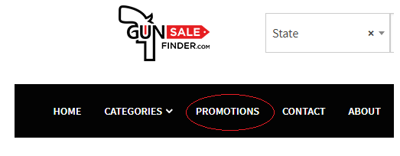

3. Contest Terms

Gun Sale Finder website can be promoted on social media such as Facebook, Twitter, Instagram, LinkedIn, Reddit, or Google+ except on forums that posting links are not allowed. Gun Sale Finder do not encourage spamming, account hijacking nor unsolicited posting. Promoters will be responsible on their own posts and Gun Sale Finder will not be held liable for any violation committed directly or indirectly by any promoters.

a. Gun Sale Finder employees are not eligible to participate in the contest. Registered dealers can participate and promote the website and their product but will not receive prizes.

b. Participants should be at least 18 years old and above, a US citizen or Permanent Resident, and can legally own a firearm.

c. Gun Sale Finder can end the contest anytime and for any reason including but not limited to software failure and loss of data.

d. All promoters must abide by terms and condition of any website, social media or internet forum where he or she is promoting Gun Sale Finder website. They must be responsible for all their action and should post only in the sites where they are authorized to do so. Gun Sale Finder will not be held responsible for any action done by any promoters.

e. Promoting Gun Sale Finder on other Deal sites is not allowed. Those points will be invalidated and promoters will be disqualified.

f. Using illegal methods like spamming, bots or traffic referral software/schemes are not allowed and will result in disqualification. Gun Sale Finder will be able to track every referring visit and can detect fake accounts used to direct traffic to our site.

g. All promoters agree to post the links honestly, provide the promo information describing the deal as what it is stated and should not deceive others by claiming false statement. Failure to do so will result in disqualification.

h. Winners should contact Gun Sale Finder within 7 days from Contest Winner announcement. Failure to do so reserved the right to Gun Sale Finder to award the prize to the next promoter.

*(Note: We should have a Promotion Dashboard where we can calculate points, detect valid entries, etc. Points system will be included in the mechanics, this will be updated later.)*

**BANNER**

We should have Banner Store where dealers can purchase their ads placement.

Banner Location:

Top Center, Top Right, Right Middle, Top Left , Left Middle, Center, Bottom Right, Bottom Left.

Option for Home Page, Individual Page, All Pages, Mobile or Desktop Only

See sample:

<https://www.buysellads.com/buy/detail/285464>

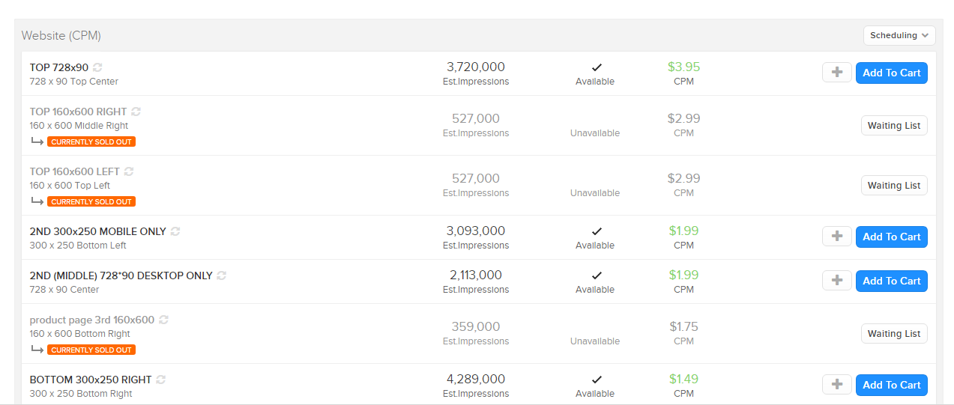

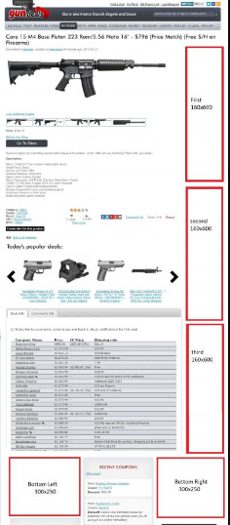 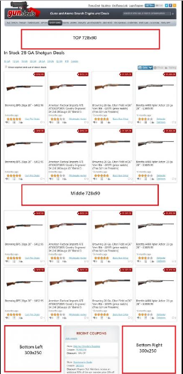 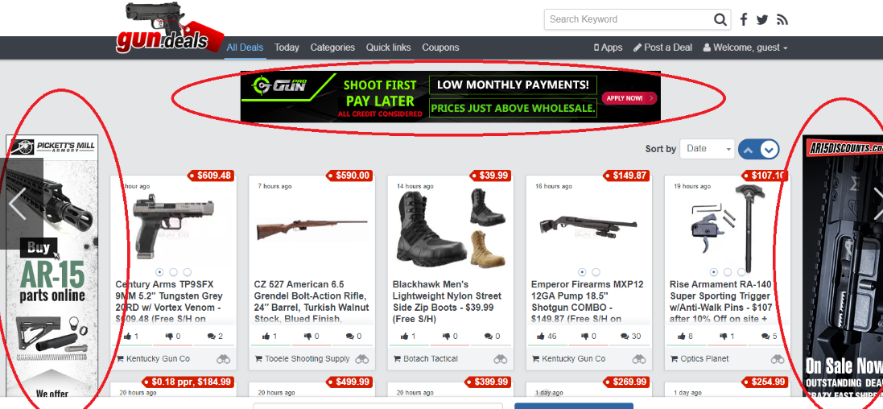

**PRIVACY POLICY**

Gun Sale Finder is an online search engine & marketplace designed to provide real time information regarding product and pricing on firearms, ammo, archery, knives and accessories. The following statements and guidelines constitute our policies and rules in using the website.

1. All users agree that they will not use Gun Sale Finder for any illegal purposes or activity.

2. Gun Sale Finder is not liable for any misuse of any item or information found in this website.

3. All users are not allowed to post personal ads, eBay, auction, personal affiliate links, giveaway or raffles.

4. Gun Sale Finder does not facilitate any sales. All sales are between the listed dealer and the customer.

5. Prices and information are constantly changing. We are not responsible for any changes or mistake in the data.

6. All users must have a registered account in order to post a deal.

7. When posting a deal, it must be the best deal posted online. Run a search using either product’s UPC or the Manufacturer Product Number (MPN) in Gun Sale Finder to make sure that you have the best deal.

8. When posting an ad, the Title should include the Product Name, Model, Amount, the Price followed by the Shipping Charge. All prices must be listed, if there are rebates the price should be listed before the rebate but on the description you can say that there is a rebate.

9. When selling ammo, the Title should include the Make, Type, the Quantity being sold, Price and Shipping Charge. Any State that the item cannot be shipped or with different shipping fees should be disclosed.

10. All listing should have accurate Description, Product Number, UPC, Specification, and have Accurate and Current Photo.

**Comments Policy:**

Gun Sale Finder is created for the Firearm Enthusiasts and Sportsmen where they easily find deals that suit their needs, exchange ideas and benefit on the information, provided in the internet. The following rules and guidelines will be implemented to encourage quality communication and mutual respect.

* No discussion promoting illegal activity
* No forms of harassment, bulgur language or intimidating behavior will be tolerated.
* Bullying and disrespectful attitude are not permitted and may result in permanent ban.
* Offensive language will result in ban. Anti-Semitic, racist , sexual orientation comments will be remove and will result in permanent ban.
* User cannot create more than one account. Will result in permanent ban.
* Any attempt to disrupt or hijack a dealer’s posting will not be tolerated
* All posting should be posted in English language
* Reposting concerning Gun Sale Finder directive or decision will be removed and poster maybe banned.
* We do not permit post containing copyright material without appropriate approval
* All deal must be posted in appropriate area.
* Private message should not be used for unsolicited advance or a form to circumvent t any rule listed Gun Sale Finder website.
* No posting of irrelevant items that are not related to the firearm industry. No Spamming.
* Not acceptable to post another person’s private information without written consent.
* Do not post inaccurate or dangerous information, or misquoting other posts.

While warnings maybe given, single or repeated violation of any of these rules may result in permanent ban. Final decision will be given by Gun Sale Finder.

**POST A PRODUCT**

**How It Works:**

This is an online marketplace that strives to offer meaningful contents to Sportsmen and Firearm Enthusiasts community. Gun Sale Finder offers each visitor a way to compare prices and stock availability in real time resulting in best deal possible for both buyers and sellers.

Sellers can post deals and see where they are rated among their peers. Buyers can see deals and rate them as per their preference. In this way, an open and transparent communication is available for all concerns.

We do not endorse the companies listed here. Rather it reflect the customers’ opinion on what they think and feel.

**Create Your Account:**

By having a dealer account you can Post ads, advertise your products and get Detailed Analysis on where you are in the market. Registered users have the right to provide their comments by rating each product or deals, participating in the forum and thereby affecting the status of the marketplace.

**Feed Your Product:**

Get more sales by streaming your catalogue on our firearm marketplace. Stream your entire online store. Make your item searchable where motivated buyers gather.

Click Here To learn on how stream your products on our website. (*link to API How To*)

**Done:**

Set back and reap the benefit of increase traffic. While we do the advertising gathering, all interested buyers, you can focus on providing your services on your best possible ways.

**OTHER ITEMS**

**Footer** (below the logo): Provide real time deals on firearms, ammo, archery, knives and accessories.

**About Us**

**Photo:** Add an Image or Graph,

**LOGO :** - adjust the size specially the one in the bottom

**DEALERS API ACCESS** *(contents for revision)*

To access paid dealers API subscription, you will need API key. For obtaining your API key, please complete the monthly recurring subscription for your desired API

Top products

Monthly Recurring Subscription for Top 150 most viewed products only

Prices for top most popular products on gun.deals website.

http://api.gunengine.com/api/dealers/v1/top-products?api_key={API_KEY}&total_results={INT}

- api_key (required)

- total_results (optional, default: 5)

Prices by UPC - Full Access to entire database

Get prices for one product by UPC.

Monthly Recurring Subscription for Full Access to entire database

http://api.gunengine.com/api/dealers/v1/search-by-upc?api_key={API_KEY}&upc={UPC}&total_results={INT}

- api_key (required)

- upc (required)

- total_results (optional, default: 5)